NHL Preseason

By Annabelle Young

The NHL preseason started on September 23. The games that were played on September 25 were; Predators vs Panthers, Senators vs Maple Leafs, Devils vs Canadians, Flyers vs Devils, Oilers vs Jets, Golden Knights vs Avalanche, and Kraken vs Flames. The teams that won were the Panthers, Senators, Devils, Devils, Jets, Avalanche, and Flames.

The teams that played on September 26 were NY Islanders at NY Rangers, Boston at Buffalo, Pittsburgh at Detroit, Tampa Bay at Carolina, Columbus at St. Louis, Minnesota at Dallas, and Anaheim at San Jose. The winners of those games were the Red Wings, Hurricanes, Rangers, Sabres, Blues, Stars, and Ducks.

This is going to be an interesting season based on what’s happened so far. Alex DeBrincat had two assists in his Detroit Red Wings debut, a 4-3 win against the Pittsburgh Penguins at Little Caesars Arena in Detroit. DeBrincat was acquired by the Red Wings in a trade from the Ottawa Senators on July 9 and signed a four-year, $31.5 million contract ($7.875 million average annual value).

Kaapo Kakko of the Rangers scored 15 seconds into the first period against The New York Islanders to make it 1-0, and Tyler Pitlick pushed it to 2-0 at 1:17.

Devon Levi stopped all 19 shots he faced over the first two periods in the Buffalo Sabres’ win against the Boston Bruins at KeyBank Center in Buffalo. Sabres 4, Bruins 1.

What do you think about the hockey season so far?

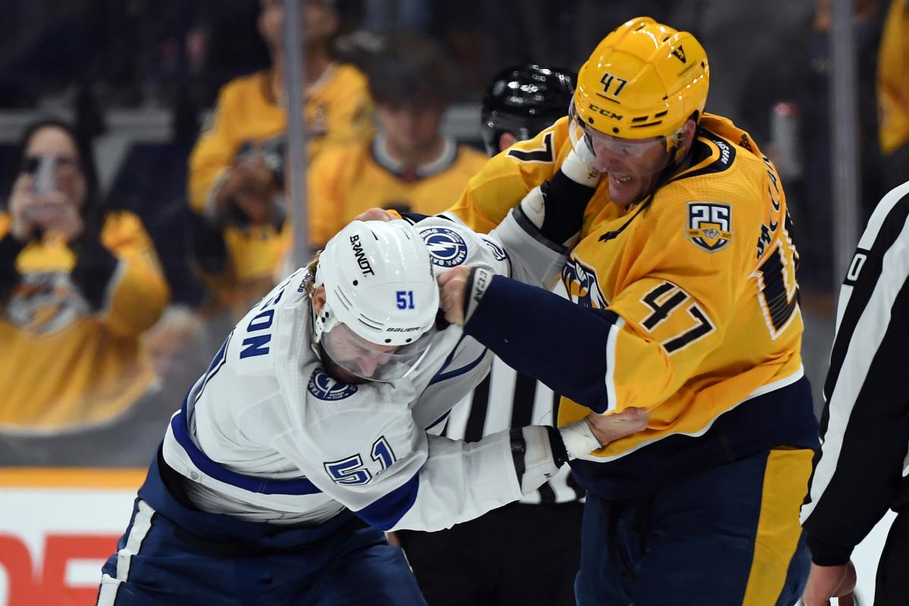

*Sep 27, 2023; Nashville, Tennessee, USA; Tampa Bay Lightning forward Austin Watson (51) and Nashville Predators right wing Michael McCarron (47) exchange hits during a fight in the first period at Bridgestone Arena. Mandatory Credit: Christopher Hanewinckel-USA TODAY Sports*

Fun Fact

—--------

The Coyotes, Sabres, Blue Jackets, Wild, Predators, Sharks, Jets, Senators, Canucks, Panthers and Kraken have never won a championship in NHL history. Out of the 11 teams, six have made at least one appearance in a Stanley Cup Final.